Concave Shapes
# Source: AI Source: Provided by: [Data Path: Persons Table -> ID Column: 1, Name_En Column: Motasem Essam] -> From: [ChatGPT] on [7/25/2026]
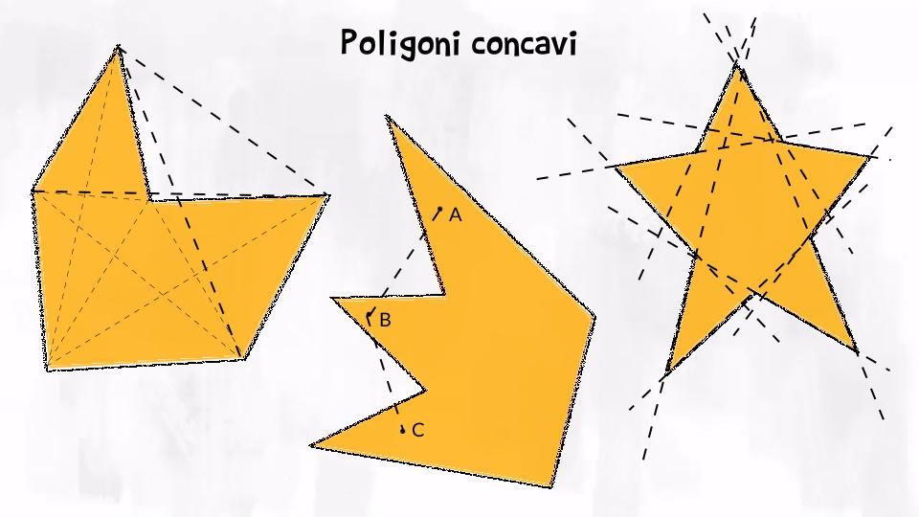
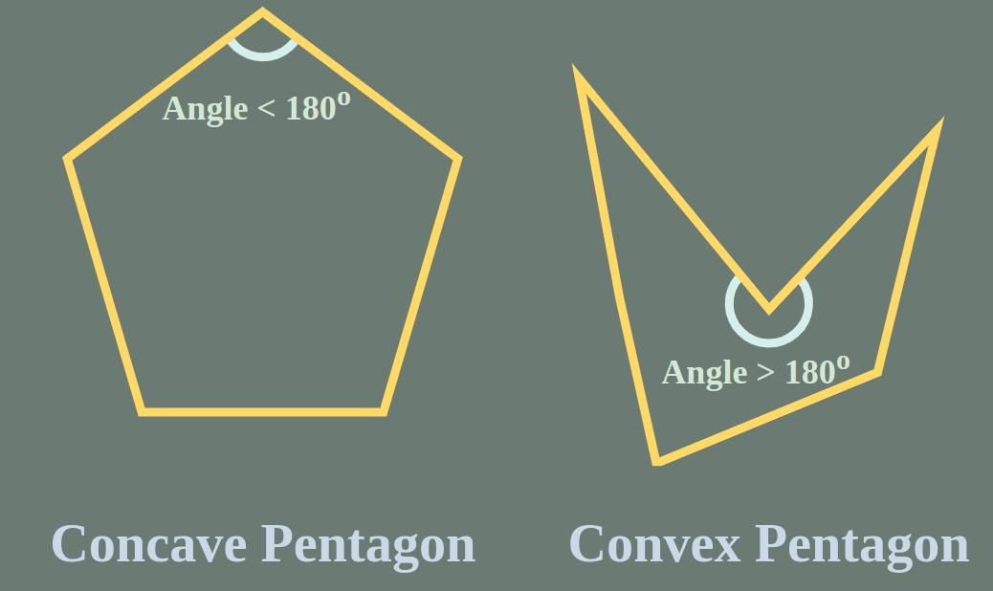
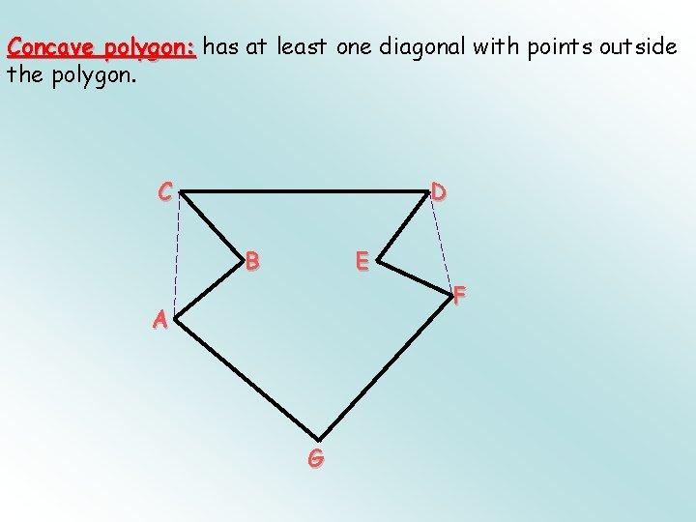
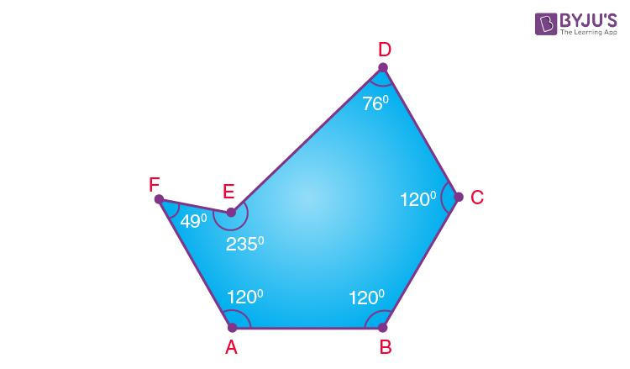
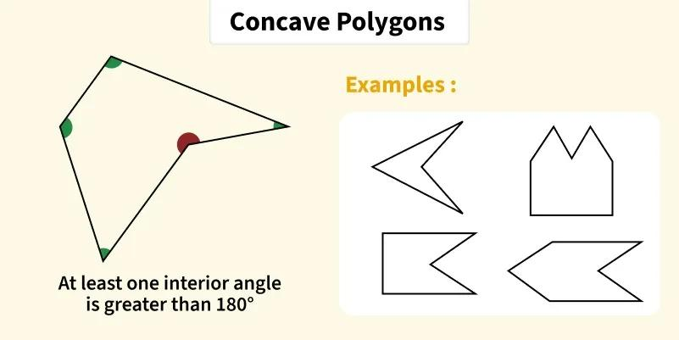

Definition
# Source: AI Source: Provided by: [Data Path: Persons Table -> ID Column: 1, Name_En Column: Motasem Essam] -> From: [ChatGPT] on [7/25/2026]
A Concave Shape is a two-dimensional geometric figure that has at least one inward indentation or "dent" in its boundary.
For a concave polygon, at least one interior angle is:
$$>{180}^{∘}$$
This inward angle causes some line segments connecting points inside the shape to pass outside the shape.

Characteristics
# Source: AI Source: Provided by: [Data Path: Persons Table -> ID Column: 1, Name_En Column: Motasem Essam] -> From: [ChatGPT] on [7/25/2026]
A concave shape:
- Has at least one inward dent.
- Has at least one interior angle greater than:
$${180}^{∘}$$
(for polygons).
- May have diagonals that extend outside the shape.
- Is a closed figure if it represents a geometric shape.
- Encloses an interior region.
- Can be regular-looking or irregular, although most concave polygons are irregular.

Illustration

Concave Polygon
# Source: AI Source: Provided by: [Data Path: Persons Table -> ID Column: 1, Name_En Column: Motasem Essam] -> From: [ChatGPT] on [7/25/2026]
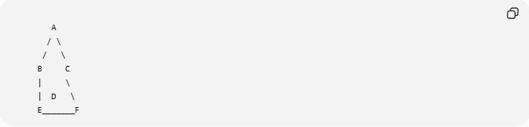
A
/ \
/ \
B C
| \
| D \
E_______F
The indentation at point D creates a concave shape.

Concave vs Convex
# Source: AI Source: Provided by: [Data Path: Persons Table -> ID Column: 1, Name_En Column: Motasem Essam] -> From: [ChatGPT] on [7/25/2026]
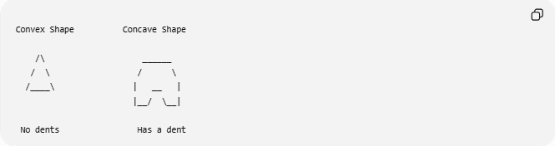
Convex Shape Concave Shape

/\ ______
/ \ / \
/____\ | __ |
|__/ \__|

No dents Has a dent

Mathematical Definition
# Source: AI Source: Provided by: [Data Path: Persons Table -> ID Column: 1, Name_En Column: Motasem Essam] -> From: [ChatGPT] on [7/25/2026]
A shape (S) is concave if there exist two points:
$$A,B∈S$$
such that the line segment:
$$\overline{AB}$$
is not completely contained inside $S$.
Meaning:
$$\overline{AB}⊈S$$

Concave Polygon Properties
# Source: AI Source: Provided by: [Data Path: Persons Table -> ID Column: 1, Name_En Column: Motasem Essam] -> From: [ChatGPT] on [7/25/2026]
1. Interior Angles
A concave polygon has at least one reflex angle:
$${180}^{∘}<θ<{360}^{∘}$$
Example:
$$θ={270}^{∘}$$

2. Diagonals
Some diagonals lie outside the polygon.
Example:
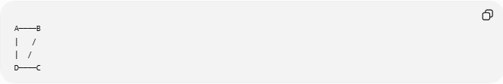
A────B
| /
| /
D────C
The diagonal may leave the shape.

3. Boundary
The boundary bends inward at one or more vertices.

Examples of Concave Shapes
# Source: AI Source: Provided by: [Data Path: Persons Table -> ID Column: 1, Name_En Column: Motasem Essam] -> From: [ChatGPT] on [7/25/2026]
Polygonal Concave Shapes
Examples:
- Concave pentagon.
- Star-shaped polygon.
- Arrow shape.
- Dart shape.
- Crescent-like polygon.

Curved Concave Shapes
Examples:
- Crescent moon shape.
- C-shaped figure.
- Bowl-shaped curve.

Mixed Concave Shapes
Examples:
- Irregular objects with inward curves and straight edges.
- Mechanical parts with cutouts.

Classification by Number of Sides
# Source: AI Source: Provided by: [Data Path: Persons Table -> ID Column: 1, Name_En Column: Motasem Essam] -> From: [ChatGPT] on [7/25/2026]
Examples of concave polygons:

Number of Sides | Example
4 | Concave quadrilateral
5 | Concave pentagon
6 | Concave hexagon
8 | Concave octagon

Real-World Examples
# Source: AI Source: Provided by: [Data Path: Persons Table -> ID Column: 1, Name_En Column: Motasem Essam] -> From: [ChatGPT] on [7/25/2026]
Concave shapes appear in:
- Crescent moons.
- Star designs.
- Building layouts with cutouts.
- Mechanical components.
- Brackets and hooks.
- Furniture designs.
- Logos.
- Tools.
- Decorative patterns.

Applications
# Source: AI Source: Provided by: [Data Path: Persons Table -> ID Column: 1, Name_En Column: Motasem Essam] -> From: [ChatGPT] on [7/25/2026]
Concave shapes are used in:
- Plane Geometry
- Computational Geometry
- Computer Graphics
- CAD (Computer-Aided Design)
- Engineering
- Architecture
- Robotics
- Game Development
- Industrial Design

Advantages
# Source: AI Source: Provided by: [Data Path: Persons Table -> ID Column: 1, Name_En Column: Motasem Essam] -> From: [ChatGPT] on [7/25/2026]
Studying concave shapes helps to:
- Model complex objects.
- Design mechanical parts.
- Analyze irregular boundaries.
- Create realistic computer graphics.
- Understand advanced geometric structures.

Limitations
# Source: AI Source: Provided by: [Data Path: Persons Table -> ID Column: 1, Name_En Column: Motasem Essam] -> From: [ChatGPT] on [7/25/2026]
Concave shapes:
- Are more difficult to analyze than convex shapes.
- May require decomposition into simpler shapes.
- Have more complex calculations for area and perimeter.
- Require special algorithms in computer graphics.

Comparison with Convex Shapes
# Source: AI Source: Provided by: [Data Path: Persons Table -> ID Column: 1, Name_En Column: Motasem Essam] -> From: [ChatGPT] on [7/25/2026]
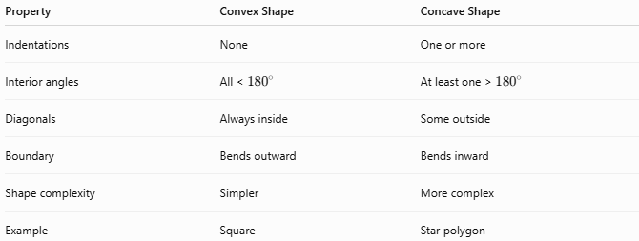
Property | Convex Shape | Concave Shape
Indentations | None | One or more
Interior angles | All < ${180}^{∘}$ | At least one > ${180}^{∘}$
Diagonals | Always inside | Some outside
Boundary | Bends outward | Bends inward
Shape complexity | Simpler | More complex
Example | Square | Star polygon

Key Points
# Source: AI Source: Provided by: [Data Path: Persons Table -> ID Column: 1, Name_En Column: Motasem Essam] -> From: [ChatGPT] on [7/25/2026]
- A Concave Shape has at least one inward indentation.
- Concave polygons contain at least one angle:
$${180}^{∘}$$
- Some diagonals may lie outside the shape.
- Examples include:
  - Stars.
  - Arrows.
  - Concave polygons.
  - Crescent shapes.

Conclusion
# Source: AI Source: Provided by: [Data Path: Persons Table -> ID Column: 1, Name_En Column: Motasem Essam] -> From: [ChatGPT] on [7/25/2026]
A Concave Shape is a two-dimensional figure with at least one inward indentation in its boundary. In concave polygons, one or more interior angles are greater than ${180}^{∘}$, causing some diagonals to extend outside the figure. Concave shapes are important in plane geometry, computational geometry, CAD, computer graphics, engineering, architecture, robotics, and industrial design, where they are used to represent complex objects, structures, and designs with internal cutouts or irregular boundaries.

